**Kali Linux Advanced Commands Report**

## ****Introduction****

This report provides a comprehensive overview of the execution of advanced Linux commands in Kali Linux. These commands are essential for file management, user administration, process monitoring, system diagnostics, and network analysis—key aspects of cybersecurity operations.

## ****Commands Executed****

### ****1. File Operations:****

ls – List directory contents

cat – View file contents

touch – Create a new empty file

cp – Copy files and directories

mv – Move or rename files

rm – Remove files or directories

### ****2. User Management:****

adduser – Create a new user

passwd – Change user password

sudo – Execute commands with superuser privileges

### ****3. Process Monitoring:****

top – Display active system processes

htop – Interactive process viewer

ps – Show currently running processes

### ****4. System Information:****

uname – Display system kernel information

lsb_release -a – Show Linux distribution details

### ****5. Network Commands:****

ifconfig – Display network interfaces (deprecated, replaced by ip a)

ip a – Show IP address configuration

netstat – Display network connections and statistics ping – Test network connectivity traceroute – Trace the path of packets to a destination

## ****Execution Output & Screenshots****

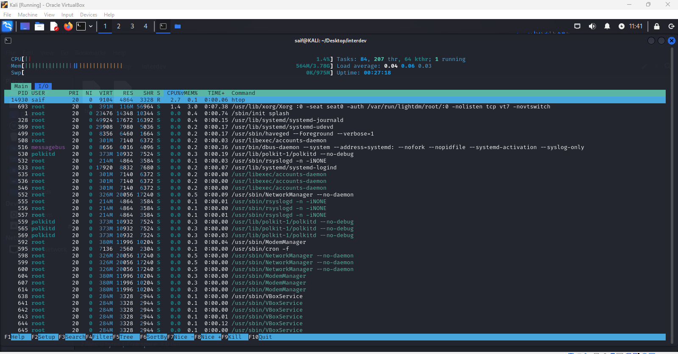

## ****Conclusion****

The successful execution of these advanced Linux commands provided critical insights into system status, user management, and network connectivity. These commands are essential for security analysis, forensic investigations, and efficient system administration.